**Part A – Create an EBS Volume and mount it to the EC2 Instance**

*Create an EC2 Volume from AWS CL*

**aws ec2 create-volume --size 10 --region us-west-2 --availability-zone us-west-2c --volume-type gp2**

Created a 10GB SSD in Region: us-west-2 and AvailabilityZone: us-west-2c

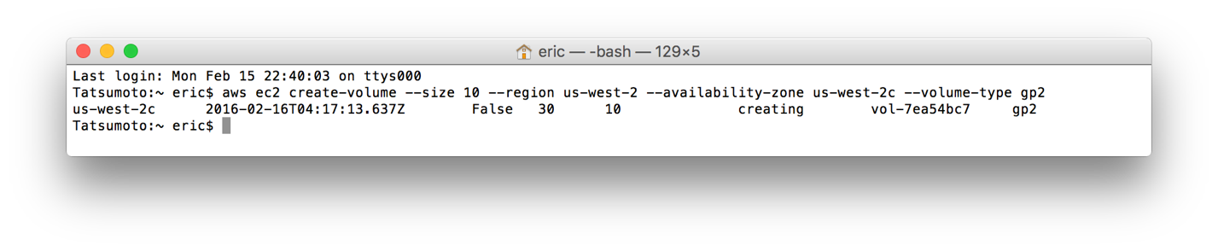

*Attach EC2 Volume from AWS CL to Instance*

First get EC2 InstanceID and the EBS VolumeID

**aws ec2 descibe-instances** (Instance ID: i-0c8cfed6)

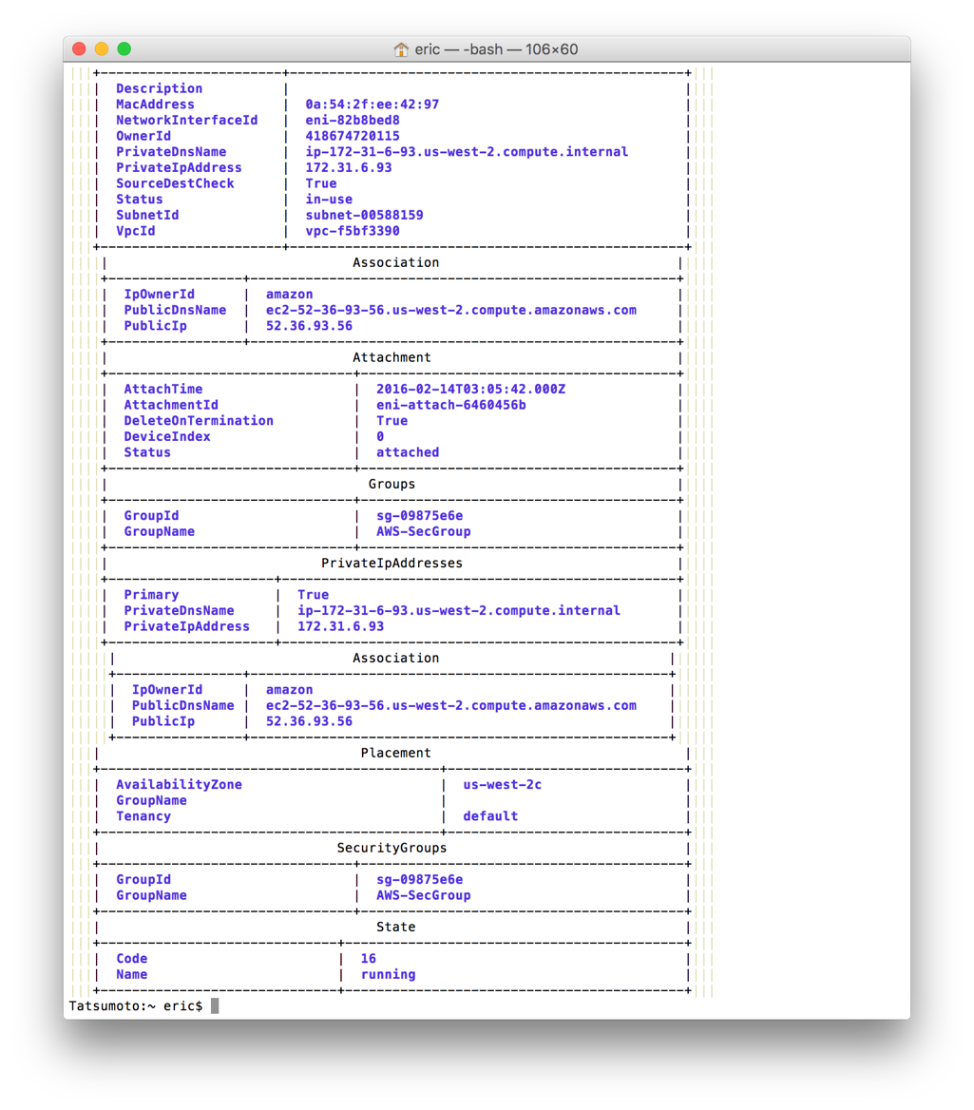

**aws ec2 descibe-volumes** (Volume ID: vol-7ea54bc7)

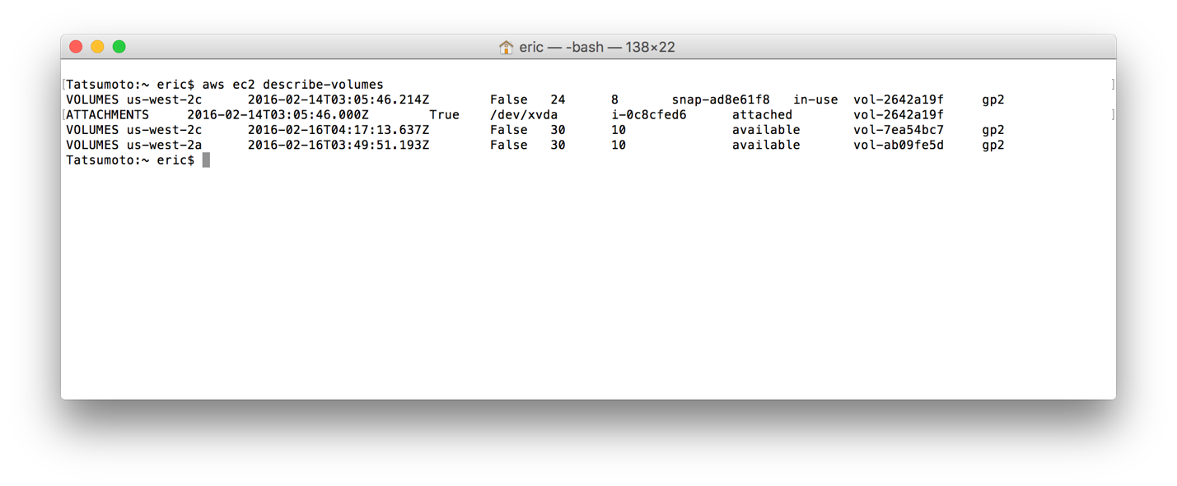

*Attach EC2 Volume from AWS CL to Instance*

**aws ec2 attach-volume --volume-id vol-7ea54bc7 --instance-id i-0c8cfed6 --device /dev/sdh**

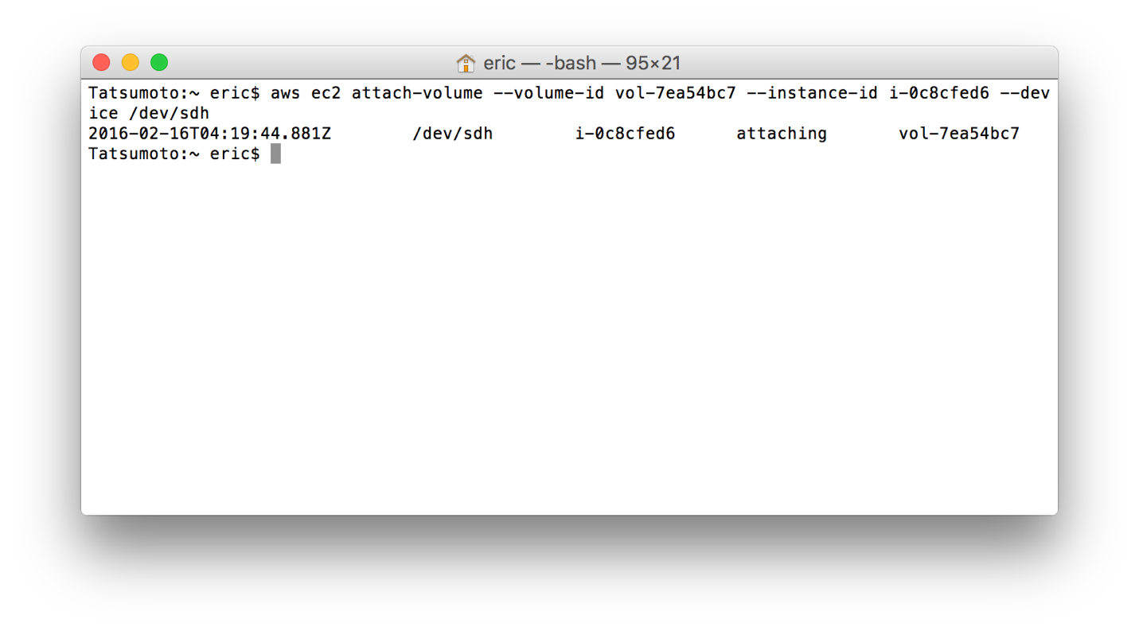

*Volume Shows Available has to be Mounted:*

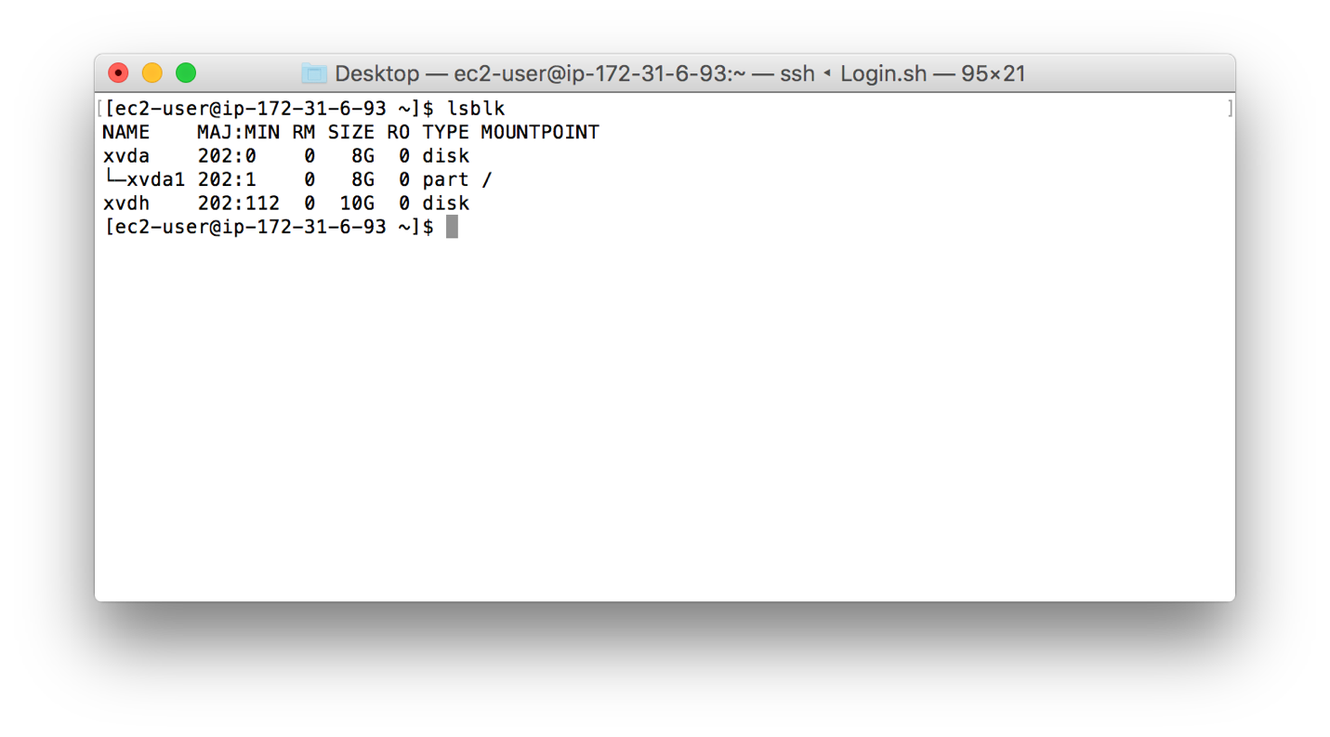

*Create a file system on the Volume:*

**sudo mkfs -t ext4 /dev/sdh**

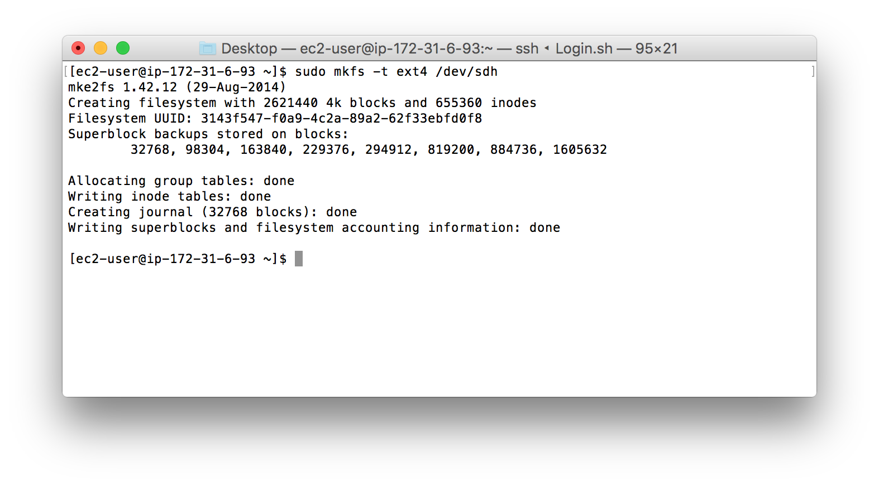

*Make a Directory/Mount-Point for the Volume:*

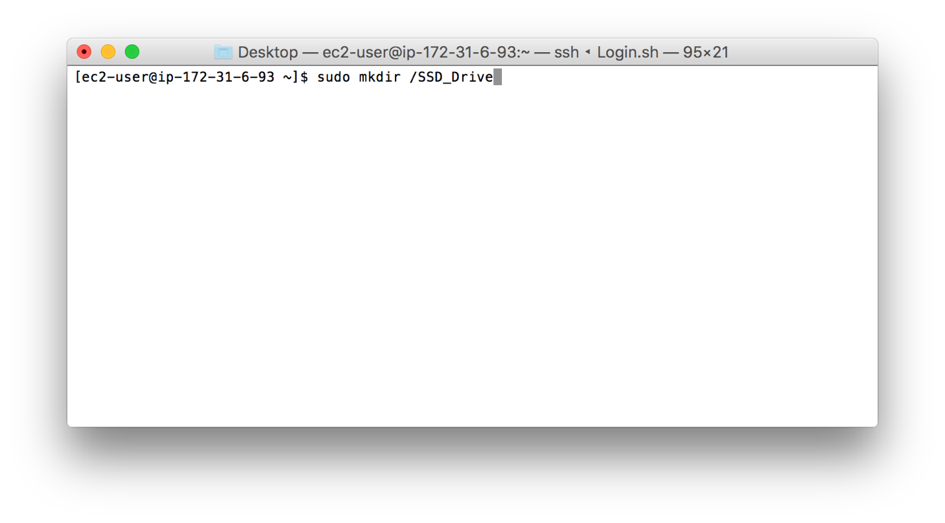

*Mount the Volume to the MountPoint:*

**sudo mount /dev/sdh /SSD_Drive**

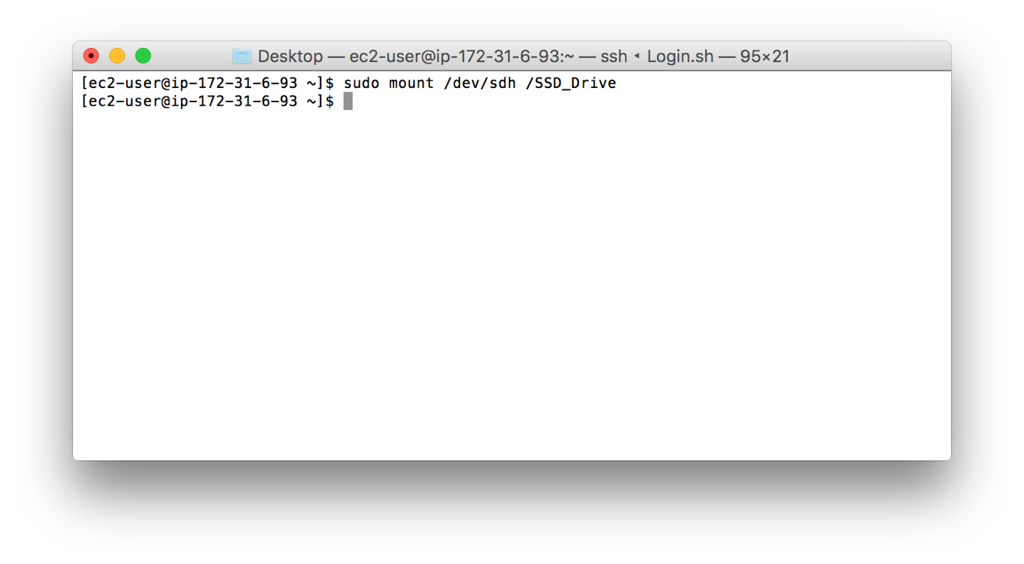

*Test Copying a File (CHANGES.txt) to the Mounted Drive*

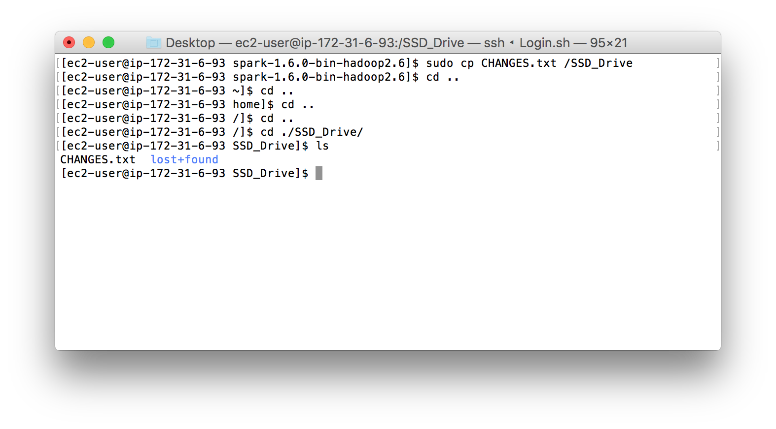

*Drive is Mounted Properly*

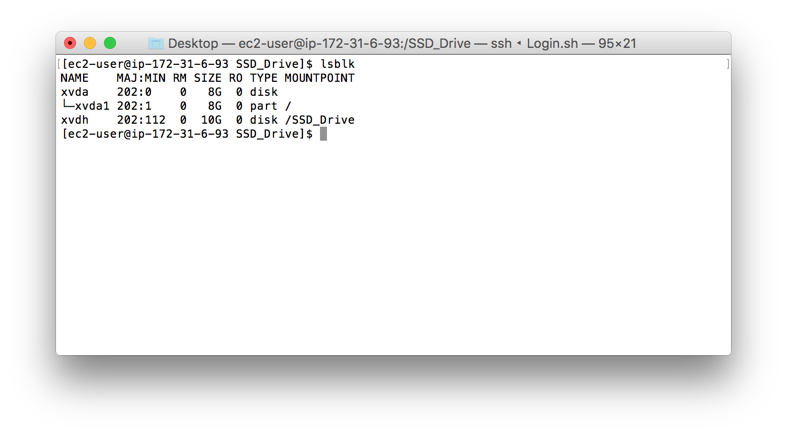

**Part B – Create an AMI Image from a Running Instance (CLI)**

*Create an EC2 Volume from AWS CL*

**aws ec2 create-image --instance-id i-0c8cfed6 --name MiniHW_AMI --description "Copy of Linux box w/ Mounted SSD"**

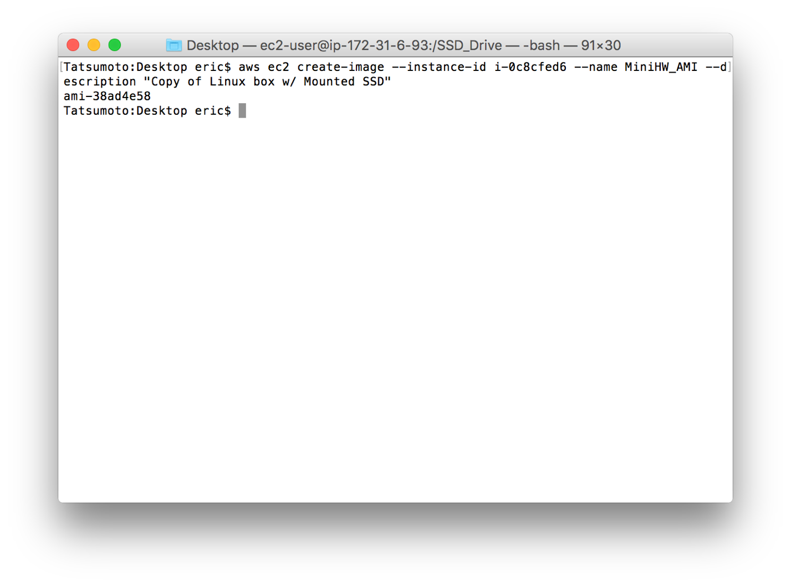

AMI ID: ami-38ad4e58

